Nice to meet you. This is Tadpole for DB Tools development project team.

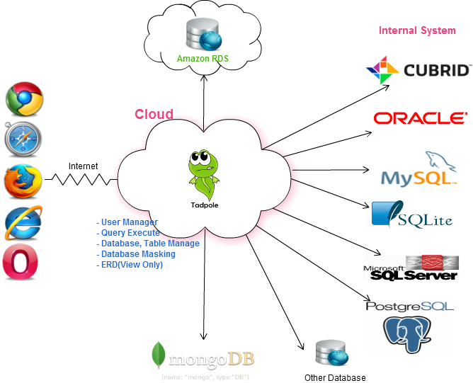
Tadpole for DB Tools is Unified infrastructure tool, various environment based interface for managing CUBRID, MySQL, MSSQL, Oracle, PostgreSQL, SQLite and MongoDB databases. It enables you to handle typical DB over the World Wide Web.

RDB Features
- User Management(Admin, Manager, User)
- Support CUBRID, MySQL, MSSQL, Oracle, PostgreSQL, SQLite Database
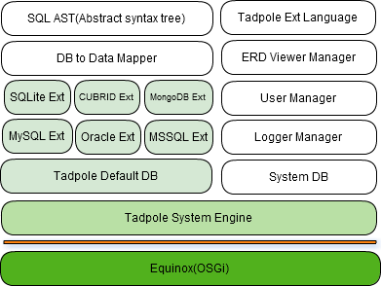
  - Select, Insert, Update, Delete
  - SQL Syntax Highlighting
  - Format SQL
  - SQL Statement <-> Java, PHP String Literal Each Convert
  - Content Assist
  - Execute SQL Statement
  - SQL Result Set to CSV
  - SQL History And Export text
  - Generate SQL Statement
(Select, Insert, Update, Delete, Table, View, Index, Procedure, Function, Trigger)
  - Generate ER Diagram(Auto Layout)
MongoDB Features
- User Management(Admin, Manager, User)
- MongoDB User Management
- Query View(Tree, Table, Text)
- Show Query plan and Console View
- Download query result
- GridFS(insert, delete, download)
- Server Status view
- Top view
- Web console view
- Current operation list and current operation kill view
- Query Profilling
- Generate ER Diagram(Auto Layout)
Commons
- Environment
more than Java 1.6.x
support system
standalone: linux.gtk.x86, linux.gtk.x86_64, acosx.cocoa.x86, macosx.cocoa.x86_64, win32.x86, win32.x86_64
server: tomcat 6.x
- Browser: Safari, Chrome, IE, Firefox, Opera ect.
- Demo video
RDB ( http://www.youtube.com/watch?v=cXNthDhxWgs )
MongoDB( http://www.youtube.com/watch?v=gUsVbin-2FM )
- Demo site : http://goo.gl/BhwQe
- Install : http://goo.gl/PGgsQ
- Download: http://code.google.com/p/tadpole-for-db-tools/downloads/list
- If you have any bug or issue, please resister at
http://code.google.com/p/tadpole-for-db-tools/issues/list
- License : EPL(Eclipse Public License)
Link
korean : https://sites.google.com/site/tadpolefordb/
english : https://sites.google.com/site/tadpolefordbtoolsen/
source and download : http://code.google.com/p/tadpole-for-db-tools/

Progress
Tadpole for DB Tools initiative at 2011.04
Version 0.0.8 SR2 start to deploy at 2012-08-05
Presentation “ Development tool & Cloud through Tadpole for DB”
-The second Korean Community Day (http://kcd.zdnet.co.kr/program.html)

0.0.9 Feature
- RDB Feature
  - Main Editor bug patch and advancement for basic function
  - DB to DB data migration
  - Test data generation
  - Re New ERD development
  - PostgreSQL, DB2 support
  - DB monitoring

- NoSQL
  - advancement for basic function
  - Apache Cassandra support
  - Modeling tool development
  - DB monitoring

